**Optimization problem:**Following is the optimization problem we have, but it looks bit complex to solve. So, we use monotonic functions to make it simple.  
**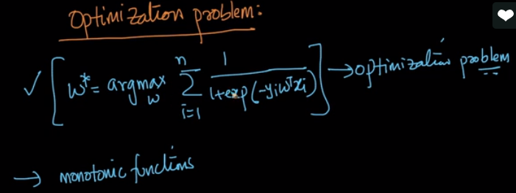  
Monotonical function**:  
Let’s say, if x increases, then g(x) of increases, this is called Monotonical increasing function.  
Other example: if x1 > x2 then g(x1) > g(x2), then g(x) is said to be monotonically increasing function.  
**Geometry definition of monotonical function:**log(x) is a monotonical function. As x increases, log(x) increases and as x decreases, log(x) decreases this happens only when x>0.   
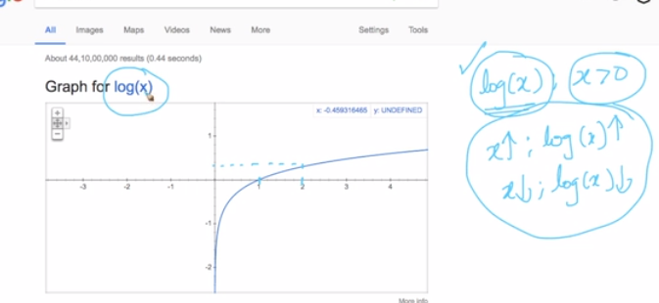  
**Let’s take an example :**We want to optimize below equation, which says that,  
Need to find x* value which is find best ‘x’ value which will give minimizes x2 value. This can be done by minima & maxima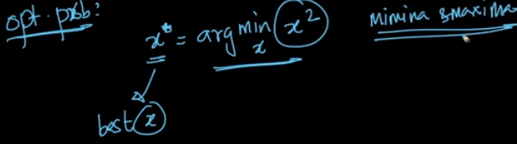  
Let’s consider below   
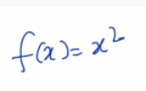  
the new equation will be  
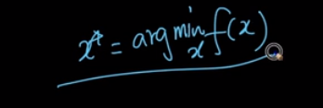

By just looking on below figure and link, we can say the minimum value is 0 meaning x* = 0 mean we can get minimum value of x2 at x* = 0<https://qr.ae/TckpFf>  
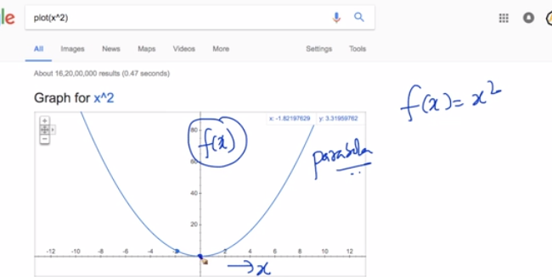  
also by looking on above we can say that, x2 is monotonically increasing when x > 0 and monotonically decreasing when x <0.  
  
Let’s assume monotonical increasing function g(x) = log(x) where f(x) = x2  
then we have new equation x’ and we calming that x* = x`  
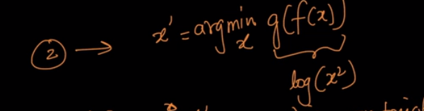  
Simple proof for x* = x` can be said as, for both the equations the minimum value is 0 by looking at plot below  
**for x’ – the minimum value occur at 0**  
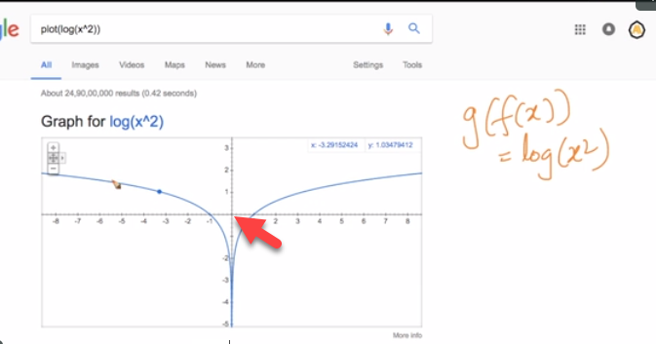 **for x*- the minimum value occur at 0**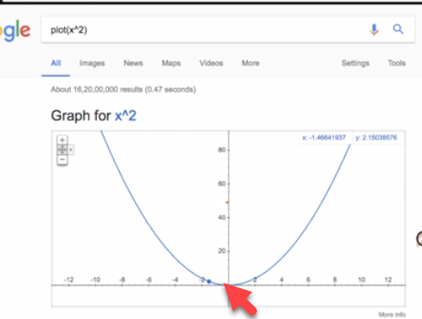

Theorem says, If g(x) is monotonic function then if we doing arg min or arg max, then  
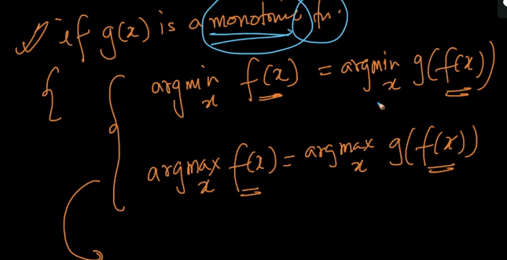

The actual equation after applying log will be as follows

